Setting Parameters for Surf

by Gerhard Brunthaler (Gerhard.Brunthaler@jku.at), 2008-05-22, V1.2

Here a minimal setting file for program Surf:
// set_param_min_01.pic by Gerhard Brunthaler, 2008-05
root_finder=d_chain_newton;
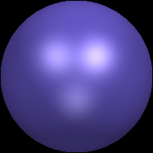
epsilon=0.0000000001;
iterations=1000;

scale_x = 0.1; // scale goes from -1 to +1
scale_y = 0.1; // sphere with radius 1
scale_z = 0.1; // fills image completely

width=200; // pixel number
height=200; // pixel number

surface = x^2+y^2+z^2 - 1;
draw_surface;
filename="output/image.ppm";
color_file_format=ppm;
save_color_image;

One can also omit the scale-values, but then image size is equal to -10 to +10!
For scale settings scale_x = 0.1; scale_y = 0.1; scale_z = 0.1; a sphere with radius 1 fills the volume completely. If scales are equal to one, then the sphere is quite small (a tenth) inside the shown volume. This is quite strange and does not agree with the manual!

Width and height can also be ommited (default value 200) but it will often be needed to enlarge image pixel numbers.

Filename=”output/image.ppm” forces file “image.ppm” to be placed in subdir named “output”.

Orientation of images:
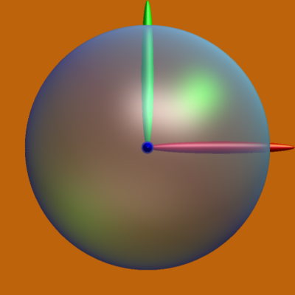
Without any coordinate rotation, the x-axis is to the right (red color), the y-axis upward (green) and the z-axis out of the plane (blue) in a right-handed coordinate system.

surface = x^2+y^2+z^2 - 1;
surface2 = (x/0.6-1)^2+(10*y)^2+(10*z)^2 - 1;
surface3 = (10*x)^2+(y/0.6-1)^2+(10*z)^2 - 1;
surface4 = (10*x)^2+(10*y)^2+(z/0.6-1)^2 - 1;

default values for first surface illumination according to manual:
ambient = 35;
diffuse = 60;
reflected = 60;
transmitted = 60;
smoothness = 13;
transparence = 80;
thickness = 10; ???

The ambient light seems to be always white and enlightens everything with homogeneous intensity as given by the value of ambient.

The diffuse and reflected lights show the intensity and colors of the light sources. Interestingly, if the intensities of the light sources are not defined, then Light1, Light3 and Light8 have non-zero intensity, all others are zero!!!

If ambient = 0, diffuse = 0, and reflected = 0, then the surface appears black. It is not visible on black background but the black surface is visible in bright backgrounds.

The value for transmitted had no influence on anything in my tests.

See the effects of different illumination values on a simple sphere on the next pages:

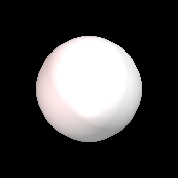
ambient = 40;
diffuse = 80;
reflected = 80;
transmitted = 20;
smoothness = 50;
transparence = 0;
thickness = 4;


Black sphere on black background!
ambient = 0;
diffuse = 0;
reflected = 0;
transmitted = 0;
smoothness = 25;
transparence = 0;
thickness = 4;

ambient = 40;
diffuse = 80;
reflected = 80;
transmitted = 20;
smoothness = 50;
transparence = 0;
thickness = 4;

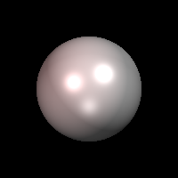
ambient = 0;
diffuse = 80;
reflected = 80;
transmitted = 20;
smoothness = 50;
transparence = 0;
thickness = 4;

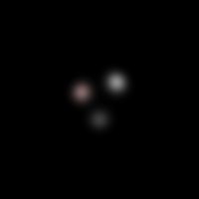
ambient = 0;
diffuse = 0;
reflected = 80;
transmitted = 20;
smoothness = 50;
transparence = 0;
thickness = 4;

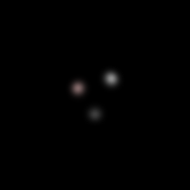
ambient = 0;
diffuse = 0;
reflected = 80;
transmitted = 20;
smoothness = 100;
transparence = 0;
thickness = 4;

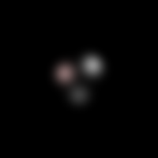
ambient = 0;
diffuse = 0;
reflected = 80;
transmitted = 20;
smoothness = 25;
transparence = 0;
thickness = 4;

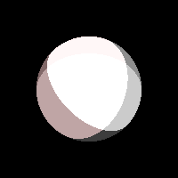
ambient = 0;
diffuse = 0;
reflected = 80;
transmitted = 20;
smoothness = 0;
transparence = 0;
thickness = 4;

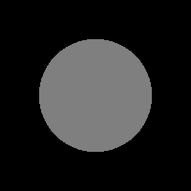
ambient = 50;
diffuse = 0;
reflected = 0;
transmitted = 0;
smoothness = 25;
transparence = 0;
thickness = 4;

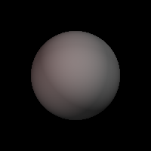
ambient = 0;
diffuse = 50;
reflected = 0;
transmitted = 0;
smoothness = 25;
transparence = 0;
thickness = 4;

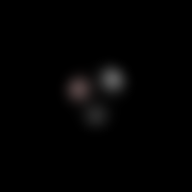
ambient = 0;
diffuse = 0;
reflected = 50;
transmitted = 0;
smoothness = 25;
transparence = 0;
thickness = 4;

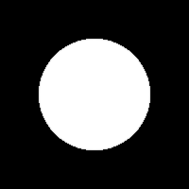
ambient = 100;
diffuse = 0;
reflected = 0;
transmitted = 0;
smoothness = 25;
transparence = 0;
thickness = 4;

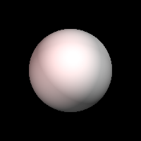
ambient = 0;
diffuse = 100;
reflected = 0;
transmitted = 0;
smoothness = 25;
transparence = 0;
thickness = 4;

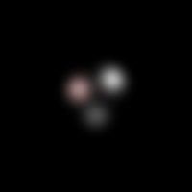
ambient = 0;
diffuse = 0;
reflected = 100;
transmitted = 0;
smoothness = 25;
transparence = 0;
thickness = 4;
The clipping parameter is quite a mystery.

from Surf-Manual page 22:
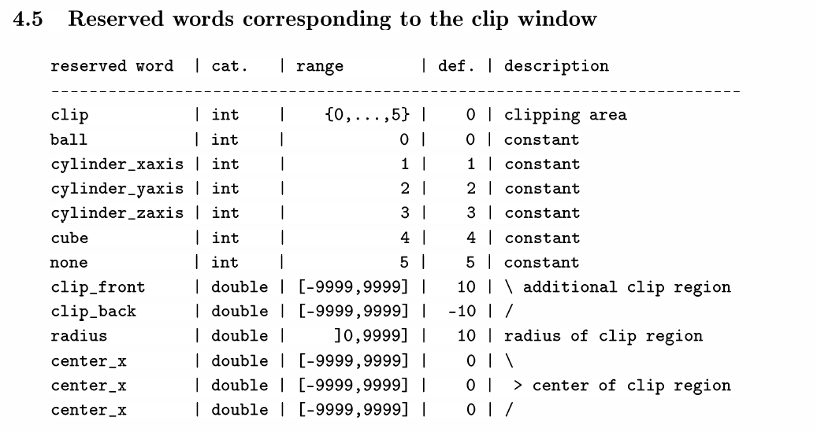

Specific settings
Clip-Settings 1:
clip=0; // ball (spherical clipping)
radius=8;
The scale of the visible output window runs from -10 to 10! Thus the radius=8 lies inside.

With
scale_x = 0.125; // scale goes from -1.25 to +1.25
scale_y = 0.125;
scale_z = 0.125;
the calculation scale goes from -1.25 to +1.25 and a sphere with radius=1
surface = (x^2+y^2+z^2-1);
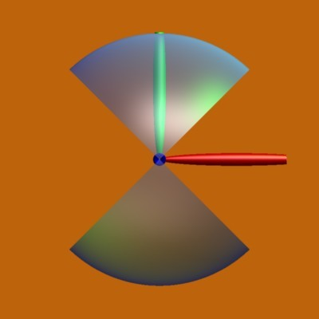
thus has a relative size of 1/1.25 = 0.8 inside the windos.
As the clipping radius works in the original scale from -10 to 10, it has the same size as the sphere for radius=8!!

The image aside shows the clipping, if
scale_x = 0.124;
scale_y = 0.126;
scale_z = 0.125;
thus in the x-direction, the sphere is just a little bit larger than the clipping region, whereas in the y-direction it is the same amount smaller. The red bar shows the positive x-, the green one the positive y-direction (for drawing of direction bars is given above).

Clip-Settings 2:

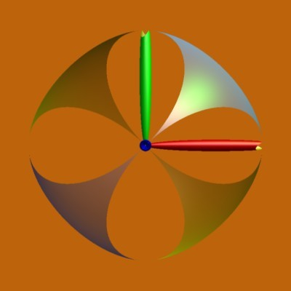
clip=1; // cylinder_xaxis
radius=1;
scale_x = 0.124;
scale_y = 0.126;
scale_z = 0.125;

Now a clipping effect is seen, if radius=1, which means that in this case the clipping coordinates are the same as the surface coordinates.

Nevertheless, the clipping effect is very strange. I cannot see a cylindrical clipping!

Clip-Settings 3:
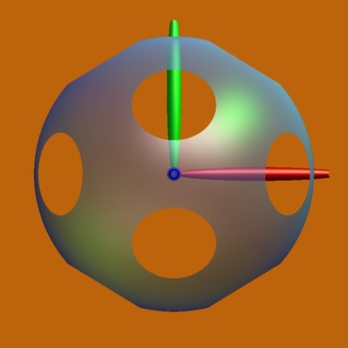
clip=4; // cube
radius=1.2;
scale_x = 0.124;
scale_y = 0.126;
scale_z = 0.125;

also the cube clipping !! … ??

I give up! loosing too much time with the clipping stuff, maybe somebody else can explain me…

In der Nacht im Bett ist mir gedämmert! Das antisymmetrische Clipping für clip=1 ist eine Tetraedersymmetrie!! Für Clip=4 seh ich’s noch nicht, ist kein Würfel, kein Oktaeder! Es sieht nach 12 Flächen aus – jede von fünf anderen umgeben, sieht nach Dodekaeder aus?

Zum Testen der Clip-Resultate habe ich jetzt viele unterschiedliche große Kugeln definiert, sodass die Schnittflächen klar erkennbar sind. Durch die Skalierung ist eine kleine Abweichung von der Kugelform vorhanden, sodass man die Begrenzung durch eine „gleich große“ Kugel (ball clip) sehen kann.

scale_x = 0.124;
scale_y = 0.126;
scale_z = 0.125; // scale goes from -1.25 to +1.25

clip=1;
radius=1.0;

surface = (x^2+y^2+z^2-1^2);
surface = surface * (x^2+y^2+z^2-(1.1)^2) * (x^2+y^2+z^2-(1.2)^2) * (x^2+y^2+z^2-(1.3)^2) * (x^2+y^2+z^2-(1.4)^2) * (x^2+y^2+z^2-(1.5)^2) * (x^2+y^2+z^2-(1.6)^2) * (x^2+y^2+z^2-(1.7)^2);
surface = surface * (x^2+y^2+z^2-(0.9)^2) * (x^2+y^2+z^2-(0.8)^2) * (x^2+y^2+z^2-(0.7)^2) * (x^2+y^2+z^2-(0.6)^2) * (x^2+y^2+z^2-(0.5)^2);

set_param_05_clip_0r8a.jpg | set_param_05_clip_1r1a.jpg | set_param_05_clip_2r1a.jpg
clip=0;  radius=8.0; | clip=1;  radius=1.0; | clip=2;  radius=1.0;
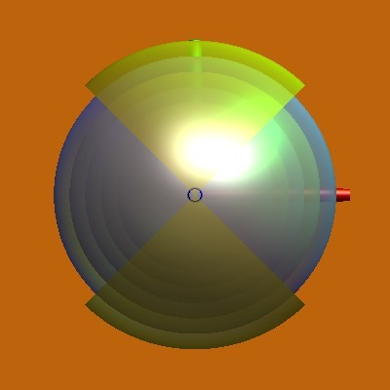 | 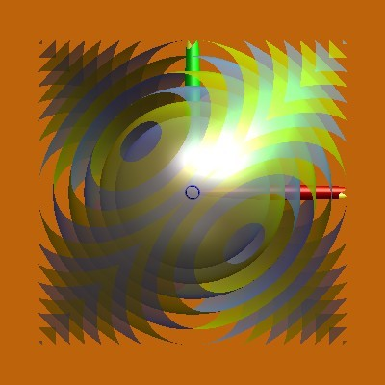 | 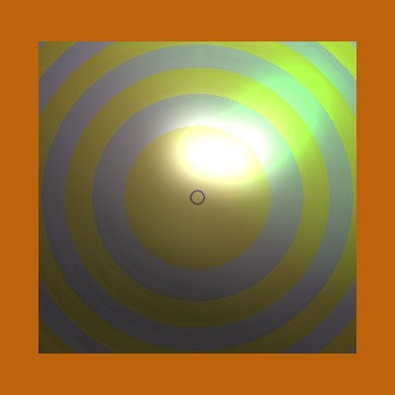
Ball Clipping! Andere Skalierung! Wegen leichter Verzerrung der Kugeln wird die äußerste Kugel gerade halb abgeschnitten. | Tetraeder Clipping! Im Manual steht aber cylinder_xaxis! | Würfel clipping!

set_param_05_clip_3r1a.jpg | set_param_05_clip_4r1a.jpg | set_param_05_clip_5r1a.jpg
clip=3;  radius=1.0; | clip=4;  radius=1.0; | clip=5;  radius=1.0;
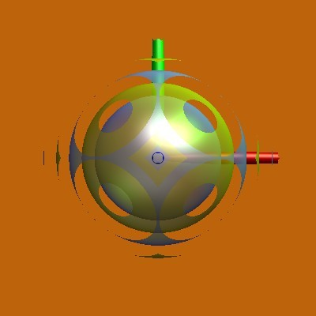 | 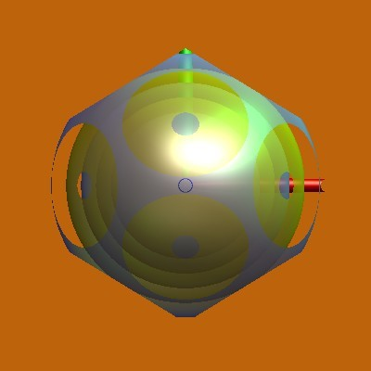 | 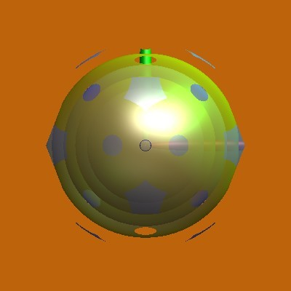
Oktaeder Clipping | Dodekaeder Clipping | Ikosaeder Clipping

set_param_05_clip_6r1a.jpg | set_param_05_clip_7r1a.jpg
clip=6;  radius=1.0; | clip=7;  radius=1.0;
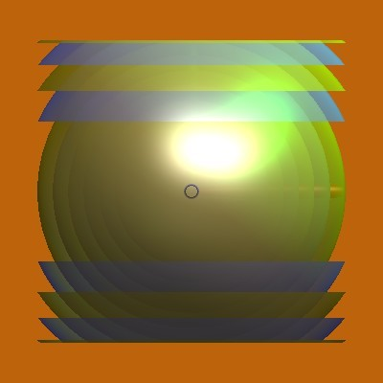 | 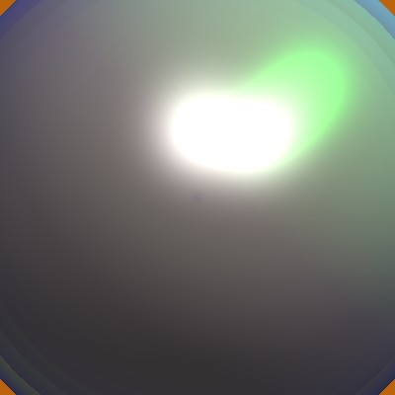 | clip=8 is equal to 7, clip=9 and larger is equal to case 0, i.e. ball clipping with different scaling!
cylindrer clipping along y-axis! | no clipping

